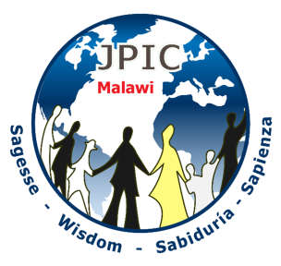
WORLD ENVIRONMENT DAY
June 5 2019

THEME: MOTHER EARTH OUR SURVIVAL

The world environment day was established to remind us the importance of our mother earth and help us to protect it from all our human activities that endanger it. The celebration of the world environment day, with time it has stimulated the global environmental awareness and encourages both political and religious action.
The day has given opportunity to people all over the world to come together and ensure that they have a clean, green and conducive environment for themselves and also for the future.
Symbol: globe, water, soil and plants

INTRODUCTION; Let us begin with a deep awareness of the divine presence in all creation. Let us see in our imagination the wonder of the Gods creation and the beauty of our mother earth including each one of us. As human being we are part of our revolving planet (Earth) as it speeds around our sun. Together let us ask the Holy Spirit to help us renew the face of the earth.

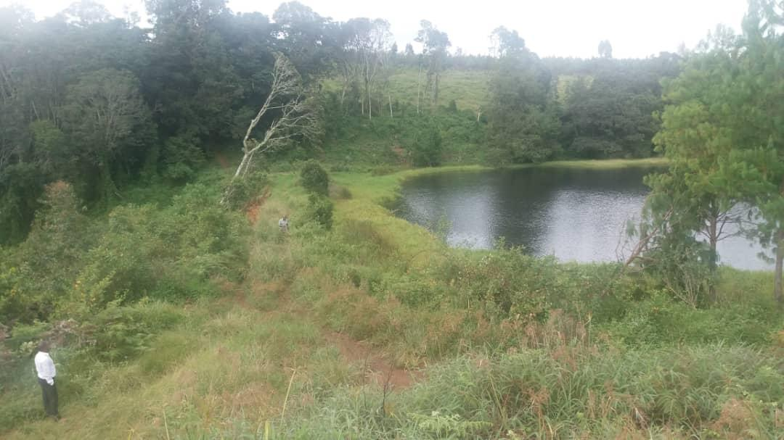

Song: Any song concerning creation

God created human being to be responsible for taking care of his creation.(Let us listen to the words from the book of Love of Eternal Wisdom)

From love of Eternal Wisdom #32 &35 (In the creation of the World and Man)
After creating all things, Eternal Wisdom abide in them to contain, maintain and renew them. It was this supremely perfect beauty who after creating the universe established the magnificent order we find there. He it was who separated, arranged, evaluated, augmented and calculated everything.
He spread out the skies, he set the sun, moon, the stars and the planet in perfect order. He laid the foundations of the earth and assigned limits and laws to the sea and depths to ocean. He raised mountains and gave moderation to all things even to the springs of waters. Finally, he said, “I was with God and I disposed everything with such perfect precision and such pleasing variety that it was like playing a game to entertain my Father and myself”
For man is his supreme masterpiece, the living image of his beauty and his perfection, the great vessel of his grace, the wonderful treasury of his wealth and in a unique way his representative on earth “By your Wisdom you appointed man to have dominion over every creature you made”

Reflection: let us reflect on the dominion in which man was given on every creature. We look at what man has failed on maintain his dominion on every creature and find out what he is supposed to do in renewing our mother earth.

(Renewing the mother earth)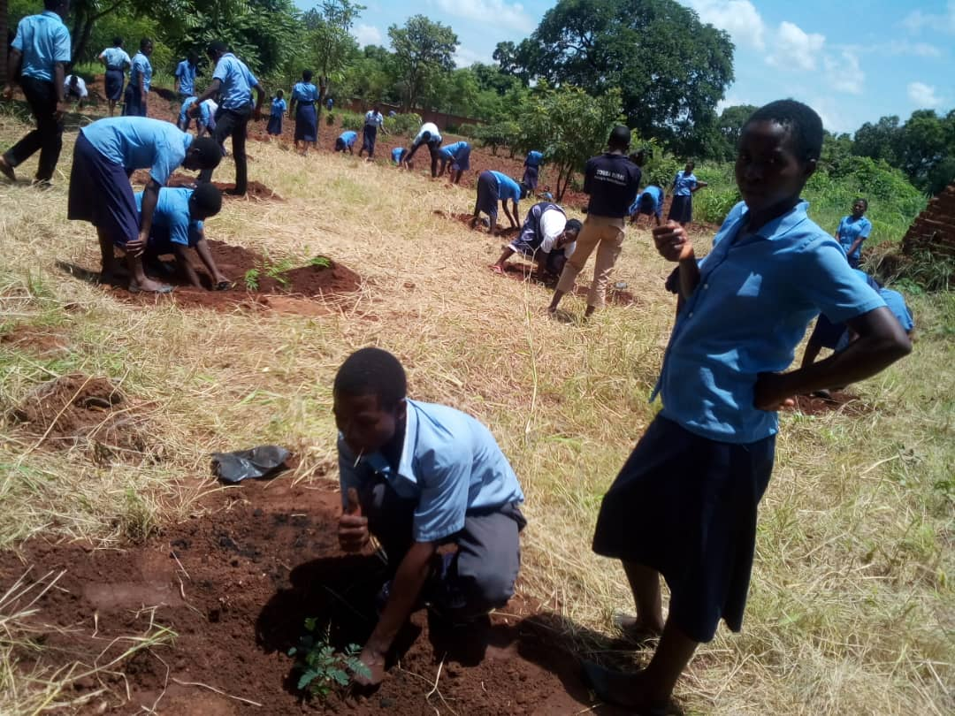

THE WORD OF GOD: GN 1: 26-31: 35

God said, “Let us make man in our own image, in the likeness of ourselves, and let them be masters of the fish of the sea, the birds of heaven, the cattle, all the wild animals and all the creatures that creep along the ground.” God created man in the image of himself, in the image of God he created him, male and female he created them. God blessed them, saying to them, “Be fruitful, multiply, fill the earth and conquer it. Be master of the fish of the sea, the birds of heaven and all living animals on the earth.” God said, “See, I give you all the seed-bearing plants that are upon the whole earth and all the trees with seed-bearing fruit; this shall be your fruit. To all wild beasts, all birds of heaven and all living reptiles on the earth, I give all the foliage of plants for food.” And so it was. God saw all he had made, and indeed it was very good.
Yahweh God planted a garden in Eden which is in the east, and there he put the man he had fashioned from the soil, Yahweh God caused to grow every kind of tree enticing, to look at and good to eat, with the tree of life in the middle of the garden and the tree of knowledge and evil.

Reflection: God created the world and saw that everything he created wad good. He entrusted whatever he created in the hands of man. Ha wanted man to care for it and make it a conducive place where he was going to settle. But the same man has forgotten the responsibility he was given now is causing a lot of destruction on the mother earth, isbusy cutting down tree making the earth bare, polluting the land, water and air with different chemicals. Now the mother earth is not as enticing as it used to be.What should we do in order to bring back the beauty of our mother earth? Is the responsibility is in our hands?
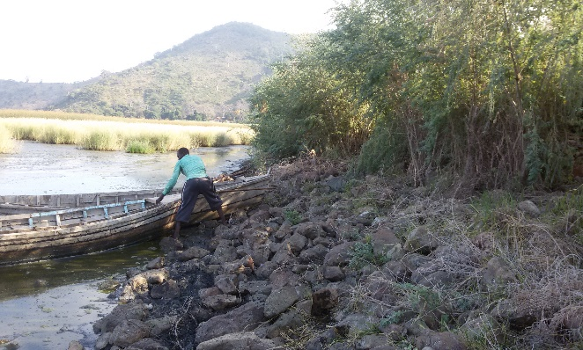(Water being polluted, fishermen struggling tofind fish)

INTERCESSIONS:
Response: We humbly ask empowerment Lord.
- Let us pray that humanity may shift from an entirely human-centred view of our existence to a realization that Earth is a communion of subjects, a oneness of which we are all a part, we humbly ask empowerment.
- We play that our efforts and those of others will eliminate or reduce the effects that come because of deforestation. R.
- We pray that all human be responsible for the care of the mother earth and avoid harmful practices that endanger the environment. R
- Let us pray that our efforts and those of others will result in companies and governments respecting the limitations of natural resources and conserving the environment, R.
- We pray that our efforts and those of others will protect the needs of future generations, R.
- We pray that those whose hearts are "crusted" by greed and thoughtlessness will mine the treasures of love within, we humbly ask empowerment. R.

Silently: Let us reflect quietly on what we can do to heal Earth from all human activities that endanger the environment. Pause to reflect

Prayer of Our father:
Let us join hands and say our Lord’s Prayer so that we can be granted the graces we need to heal our mother earth.

The last song: Thanking God for the wonder of creation

