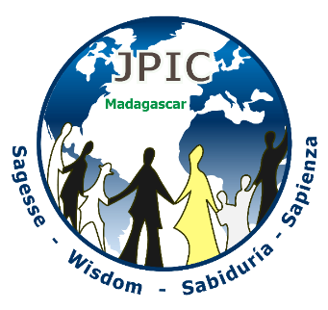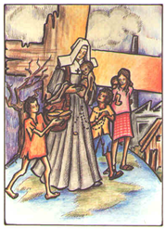 **INTERNATIONAL CHILDREN’S RIGHTS DAY- 2019**

**Theme:** Children enjoying their rights, vector of a new world.

**Setting:** globe, photo of Marie Louise with children.

If possible, invite children to pray with the community.

**Introduction**

Nothing is more important than building a world in which all children have the opportunity to develop their full potential, to grow in good health, in peace and dignity. Thus, we are invited to be in solidarity with children who have no voice; those whose lives seem meaningless. Therefore, our prayers aim at fostering prayer in the world for all vulnerable and homeless children. We also wish to increase our understanding and acceptation of all these children, and to open our hearts that sometimes does takes them for granted. Lord, give us a new heart so we can love the children as you love them.

**Song: A song concerning children**

**A few suggestions:** **Smile, don’t you know God loves you,**

**or *All the Time***

***or This Little Light of mine…or any other song***

**Prayer:**

Lord Jesus, you blessed the little children saying: “Let the children come to me, for the Kingdom of heaven belongs to them.” Today, many children suffer from all types of living conditions. They are victims of war, famine, genocide, terror and torture and many children are orphans or slaves, living in camps, on the streets, in the sewers, in garbage, in the mud. Many children are sick, exploited, deprived of love and education, desperate and alone. Lord, we want dpray especially for these children.

Listen to our voices throughout the world. Free these children from despair. Let no child feel deprived of your love. Help us to show our affection and our special attention to the children, for you, Christ Wisdom experienced the love of your parents full of respect and desire to live. Come, Christ Wisdom, in these children. Come intensify our initiatives for your children. Lord, you love children very much and you want them at your side. However, so many adults have other intentions.

**Reflection**

Let us observe the photos inviting us to be more aware of the reality that children live in our world.

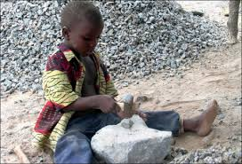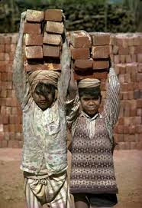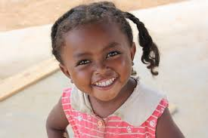

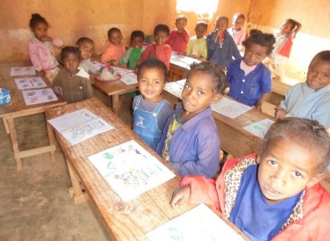

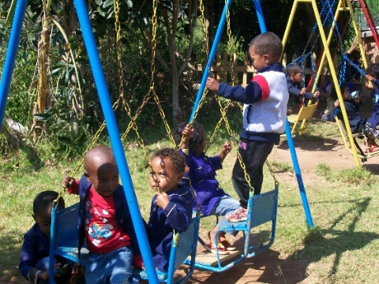

**Moment of silence**

**Sharing:** Let us evoke the feelings that dwell in us from looking at these photos.

**Song:** Find an appropriate song

***Word of God*:** Matthew 25: 40

“Truly, I say to you, every time you did this to one of these little ones, you did it to me.”

**Prayer of forgiveness:**

**Ref.**: Grant to us, O Lord, a heart renewed, recreate in us your own Spirit Lord.

1. Forgive us, Lord, for the harm we can do to children by rejecting them, abandoning them. We have wounded their hearts. Lord, we pray to you.

2. Forgive us, Lord, for we did not give the children what they needed: attentive listening, material goods for their studies, time to play. Lord, we pray to you.

3. Forgive us, Lord, for not seeing those children who needed our affection and to whom we paid no attention. Lord, we pray to you.

Lord, you said: “Let the little children come to me and do not stop them. The Kingdom of God is for those who are like them.” Help us, Lord, to spread equality and respect for all the children we meet throughout the world. Amen.

**Following the examples of our Founders:**

In Dinan, in 1706, Father de Montfort found, on the street, a leper covered with ulcers. *“He picked him up, put him on his shoulders”*, brought him to the house of the missionaries shouting: *“Open the door to Jesus-Christ.”*

*“If I were cloth, I would give myself to clothe the poor.”*

**Recommendations from our Rule of Life**

Our apostolic commitments favor the development of the whole person through education, health care, social action, pastoral work and all other activities related to our charism. To meet current challenges, we work to liberate the individual and promote the development of peoples so that “they become architects of their own destiny”. RL 3

**Soft Music**

**Prayer of Intercession**

With all the children of the world, through the intercession of the Blessed Virgin, let us implore, Jesus Mercy, who calls them to the joy of salvation.

**Ref :** O Lord, hear my prayer, O Lord, hear my prayer. When I call answer me. O Lord, hear my prayer, Lord, hear my prayer. Come and listen to me. *(Taizé)*

1- Let us pray for the homeless and abused children that they may have the opportunity to grow up with their parents.

**Ref** : O Lord, hear my prayer, O Lord, hear my prayer. When I call answer me. O Lord, hear my prayer, Lord, hear my prayer. Come and listen to me. *(Taizé)*

2- Let us pray for the illiterate and hungry children that they may have the right to education and to fulfillment.

**Ref :** O Lord, hear my prayer, O Lord, hear my prayer. When I call answer me. O Lord, hear my prayer, Lord, hear my prayer. Come and listen to me. *(Taizé)*

3- Let us pray for the children victims of war and violence. May they find good Samaritans to relieve their suffering.

**Ref :** O Lord, hear my prayer, O Lord, hear my prayer. When I call answer me. O Lord, hear my prayer, Lord, hear my prayer. Come and listen to me. *(Taizé)*

*Participants may freely contribute intentions according to the reality of their country.*

**Our Father**

**Final Prayer**

Lord God, loving Father of all children, you gave us the gift of children and you entrusted to us the care of their education and their future. Into your hands, we commend their future. Keep them from evil, protect them from dangers. Make them firm in faith, perseverant in prayer and in education, and beyond reproach in the conduct of their lives. Assist us, Lord, that our behavior never be a cause of scandal, but a light that leads them to the good. Amen.

**Final Song :** one of the suggested songs above

Or a song on Mary and the poor that you know.