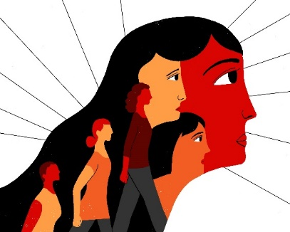 **INTERNATIONAL WOMEN’S DAY**

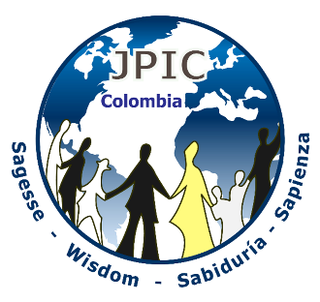 **MARCH 8, 2020**

***« Who can find a virtuous wife? Her worth is far above rubies! »***

***(Proverbs 31, 10)***

Image : ONU MUJERES COLOMBIA

**Decorative Symbols**: Crafts made by women.

A lit candle

***Presentation:***

In order to understand the verbal and non-verbal language of women in all its splendour, let us turn to the Virgin Mary- «modèle par excellence». She who reveals how to live our life, announcing the Good News, she who is the defender of Justice, woman of the people, woman in solidarity with others, faithful missionary… ; day after day, she teaches us the mission of women in the world.

«***The Virgin Mary and the Church***. *The maternal duty of Mary toward (human beings) in no wise obscures or diminishes this unique mediation of Christ, but rather shows His power. For all the salvific influence of the Blessed Virgin on (people) originates, not from some inner necessity, but from the divine pleasure. It flows forth from the superabundance of the merits of Christ, rests on His mediation, depends entirely on it and draws all its power from it. In no way does it impede, but rather does it foster the immediate union of the faithful with Christ.*  »

(Lumen Gentium 60)

*This maternity of Mary in the order of grace began with the consent which she gave in faith at the Annunciation and which she sustained without wavering beneath the cross, and lasts until the eternal fulfillment of all the elect. Taken up to heaven she did not lay aside this salvific duty, but by her constant intercession continued to bring us the gifts of eternal salvation. By her maternal charity, she cares for the (brothers and sisters) of her Son, who still journey on earth surrounded by dangers and cultics, until they are led into the happiness of their true home. Therefore the Blessed Virgin is invoked by the Church under the titles of Advocate, Auxiliatrix, Adjutrix, and Mediatrix*

(Lumen Gentium 62)

**Hymn:** Theme: celebrating life

**Small group sharing:**

On a sheet of paper, the participants write the names of women who have touched their lives, whether personally, in their families, in society, in the Church. To each person named, we assign one aspect of Wisdom. Place the names of these women and their qualities in a circle around a lit candle. Proclaim the names and qualities of these women out loud.

**Hymn** about life*.*

**Moment of interiorisation**

*The following quotations are read by different persons, leaving a short pause between each quotation.*

**How Proverbs describes an exemplary woman**:

**1.** Proverbs 31:16-18

She considers a field and buys it;  
     out of her earnings she plants a vineyard.    .  
She sees that her trading is profitable,  
     and her lamp does not go out at night

.

# 2. Proverbs 31:20-21

She opens her arms to the poor  
     and extends her hands to the needy.  
When it snows, she has no fear for her household;  
     for all of them are clothed in scarlet.

# 3.Proverbs 31:26

She speaks with wisdom,  
     and faithful instruction is on her tongue.

# 4.Proverbs 31:28-29

Her children arise and call her blessed;  
     her husband also, and he praises her:

“Many women do noble things,  
     but you surpass them all.”

**SPONTANEOUS SHARING**

**1. What have I learned from these readings?**

**2. What am I invited to change in my life after having read these passages from Proverbs?**

**3 What mission does God give to women? .**

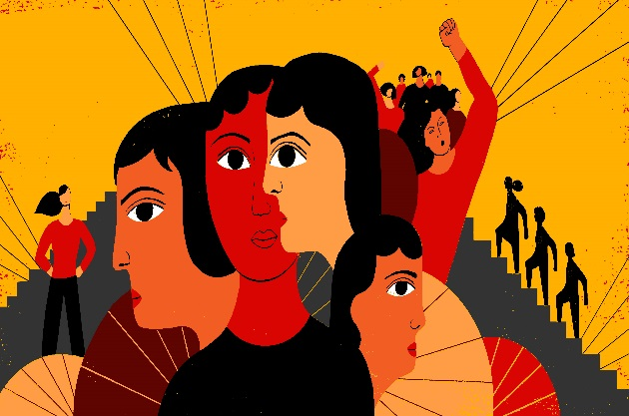

**Hymn:**Theme: Hope

***PROCLAMATION AND INTENTIONS***

We proclaim out loud those areas in which women are victims of violence. Time of silence to reflect on this.

**ASSIGNMENT*:***

During the last decade, we, women has massively entered the workplace, but statistics show that we are still in a precarious situation as workers- we carry out tasks that are the least important; and when we go home at the end of the day, we start another day’s work carrying out the same tasks. The present economic policies allow for the firing of many women who are not able to defend their rights.

**Let us pray so that women may experience stable employment and improved working conditions.**

**Let us also pray that women may receive equal pay with that of men…since for equal work there should be equal salaries.**

**Let us pray that public policies provide free care for children while their mother is at work.**

***Human trafficking:***

Human trafficking is the illegal sale of persons as slaves for reproduction, for sexual exploitation, for forced labour, for the removal of internal organs, servile marriage, for forced recruitment. It is an international crime against humanity, which violates human rights and is considered a form of slavery. On the world level, it comes third, after the traffic of arms and that of drugs. It is estimated that there are 21 million persons in slavery. Women are the most affected by this social evil.

**Let us pray that all the networks of human trafficking in South America and in other countries of the world be completely dismantled.**

**Pray that help be given to women, teenagers and little girls coming out of human trafficking, that they may start living life to the fullest again.**

***Violence:***

Violence is a mechanism of social control that serves to reproduce and maintain the status quo of male domination by becoming structural and instrumental. The violent treatment of women copies models learned and transmitted from generation to generation. Violence has become a socially accepted thing, minimising this evil.

**Let us pray that our society may become fully aware of this evil, and that we may not accept these different types of violence as natural ways of acting, but educate the next generation in treating others with equity and respect.**

**Pray for those women subject to violence at home, in the workplace, within their family and other relationships, that the God of life guide them and help them acquire the necessary tools in order to free themselves from these situations.**

***Feminicide:***

Feminicide is one of the most extreme forms of violence against women: it is the assassination of a woman by a man who considers her as his property. In Latin America, the number of feminicide in 2017 was 12 a day and is increasing.

**Let us pray that a cultural change will happen in all our society so that women are no longer treated as objects that disappear, are hit, mistreated or even killed.**

**Let us prayer for those children who are witnesses of such mistreatment of women.**

**Pray that justice free of stereotypes and of gender biases bring about quick resolutions to the mistreatment of women.**

***Armed Conflict:***

Indigenous women, peasant women, Afro-Columbians, refugees, migrants, victims and defenders of human rights have been forced into violence in different parts of the world at the expense of their body, of their family, of their community and of their territory.

**Let us pray for those who express their truth through resistance, healing and forgiveness as they work to bring about a peace arising from reconciliation and justice.**

**Let us pray that they may transform their lives without repeating the horrors of war, counting on the strength and justice that is found within them as they build a new society.**

**Let us pray that all of us will recognise and guarantee the value of the work of women victims of armed conflict as well as that of women leaders who work to defend human rights and life itself.**

***Political Positions:***

In the majority of countries, the presence of women in politics is important. They challenge competition in the exercise of administration; they help transform unjust conditions and pay attention to the need of developing remote areas.

**Let us pray that they may:**

* **Carry out their roles with transparency and a strong sense of responsibility.**
* **Contribute to the implementation of just conditions for women.**
* **Work towards the involvement of women in political and social action.**
* **Assure that violence towards women is penalized.**
* **Work towards the involvement of women in bringing about peace in their respective territories.**
* **Administer those projects that promote women’s contribution towards the defense of life.**

**Hymn:** Theme: life creation or other

***Final prayer***

*Expressing solidarity by hugging each other or holding hands, we recite the Our Father*

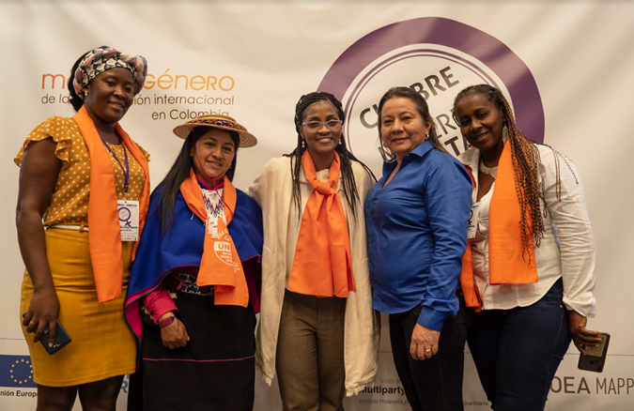

Photo : <https://colombia.unwomen.org/es/onu-mujeres-en-colombia/las-mujeres-en-colombia>

**BIBLIOGRAPHY**

* Dogmatic Constitution Lumen Gentium
* New International Version of the Bible
* <https://colombia.unwomen.org/es/noticias-y-eventos/articulos>
* [www.bbc.com/mundo/noticias-america-latina](http://www.bbc.com/mundo/noticias-america-latina)
* [www.nodal.am/2017/11/america-latina-la-region-mas-violenta-las-mujeres](http://www.nodal.am/2017/11/america-latina-la-region-mas-violenta-las-mujeres)
* You Tube