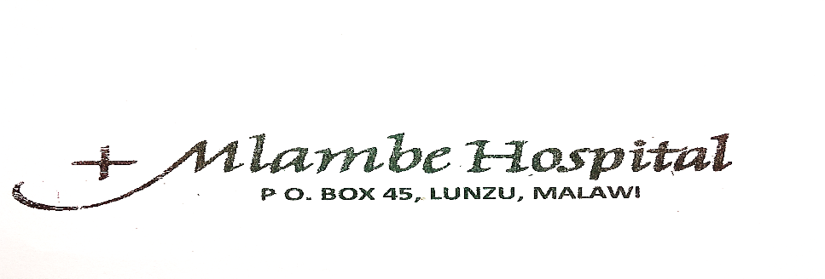
Introduction
Mlambe hospital is found in Blantyre district. Since Blantyre district does not have a district hospital, it is used as a district hospital. It is one of the most reliable hospitals in Malawi. Because of this, it serves many clients coming from both the catchment area and neighboring districts. Since it is along M1 Road, it is screening many people, including truck drivers passing by from South Africa, Tanzania and Mozambique. Therefore in order to combat and prevent more cases of COVID 19 pandemic the hospital’s management team and staff has carried out the following interventions.
Provision of water, buckets and hand washing soap:
Management is providing these facilities in strategic points for all members of staff, guardians and patients. In addition to this, in order to ease pressure on work for cleaners and guards to draw water, sinks have been constructed at the gate, outside the reception and at the gate near the laundry as portrayed below.
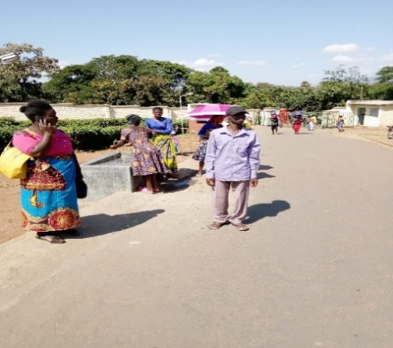
Provision of hand sanitizers to all members of staff:
Management is providing hand sanitizers to all members of staff, and in all sections of the hospital, a 500ml bottle of hand sanitizer is provided. While all nurses and medical personnel, are provided with a 110ml bottle each, which is being refilled from time to time.
Health talks to patients and guardian on prevention of COVID 19:
Every morning after morning devotion at the reception, health-talks on prevention of COVID 19 and strategies put in place by the hospital to prevent COVID 19 are presented as follows:
- All ambulating patients do not need a guardian.
- All admitted patients, require only one guardian
- Visitors like: community friends, relatives and small Christian communities are not allowed to visit patients inwards and to proceed into the hospital.
- Encouragement to practice hygiene through the washing of hands before entering the hospital, from time to time and when existing the hospital.
- Number of people collecting dead bodies from the mortuary is limited to fifteen.
One guardian, one patient:
Since guardians are not allowed in the hospital, a small guardian shelter is being constructed as a waiting area for guardians bringing food to patients.
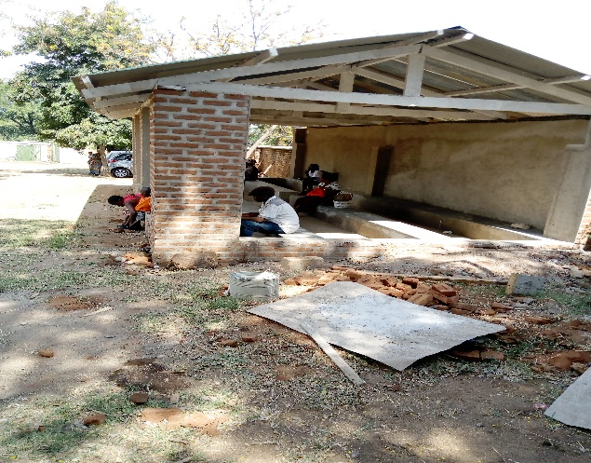

Sensitization meetings and Trainings:
Hospital advisory committee and chiefs from all 70 villages found in the hospital’s catchment area were sensitized, so that they pass information on COVID 19 to the people in their villages.
Sensitization meetings and trainings of both support and technical staff on COVID 19 management has been conducted as portrayed below.

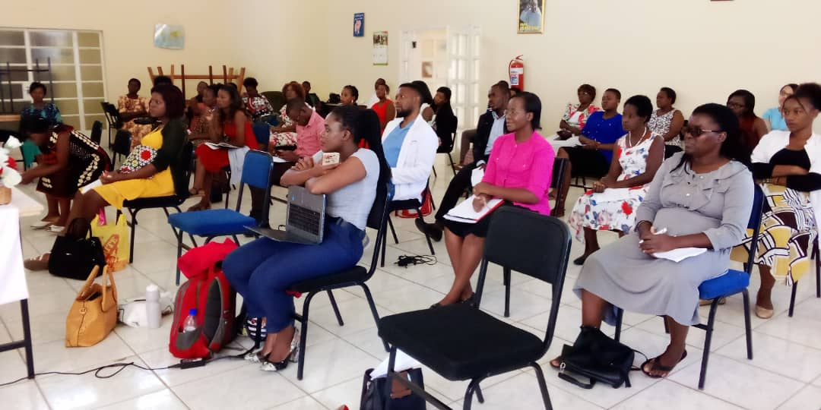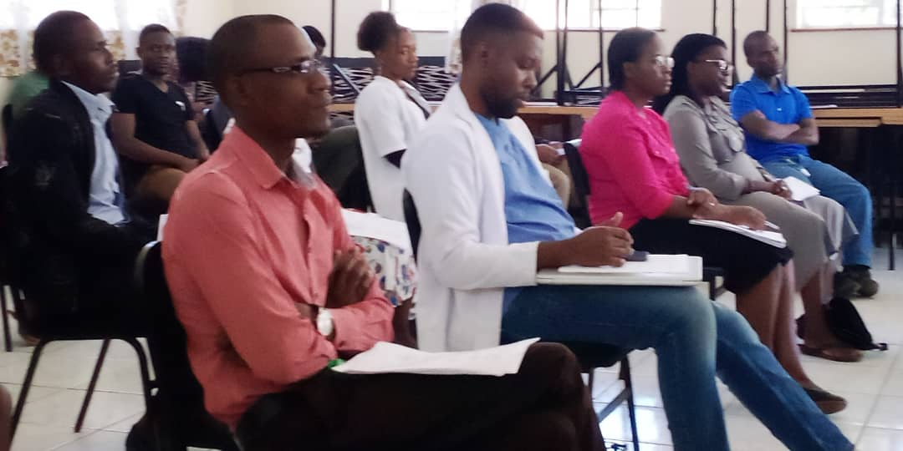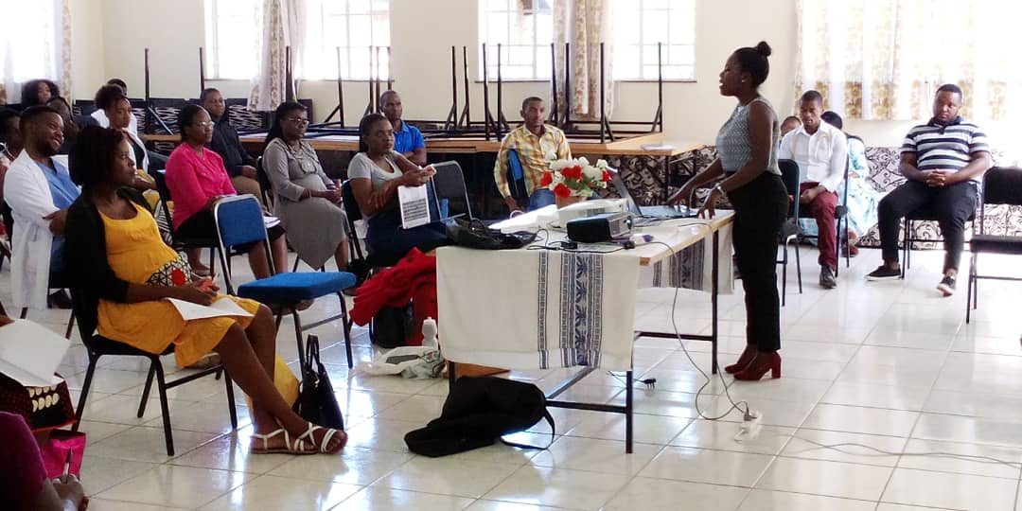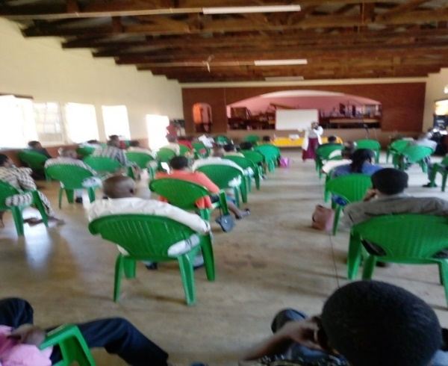
Screening of patients, guardians and staff:
Two tents have been mounted at the entrance of the hospital, where screening of members of staff, guardians and patients entering the hospital is done. Suspects can be detected before entering the hospital and assisted accordingly to avoid multiple contacts, as portrayed below.
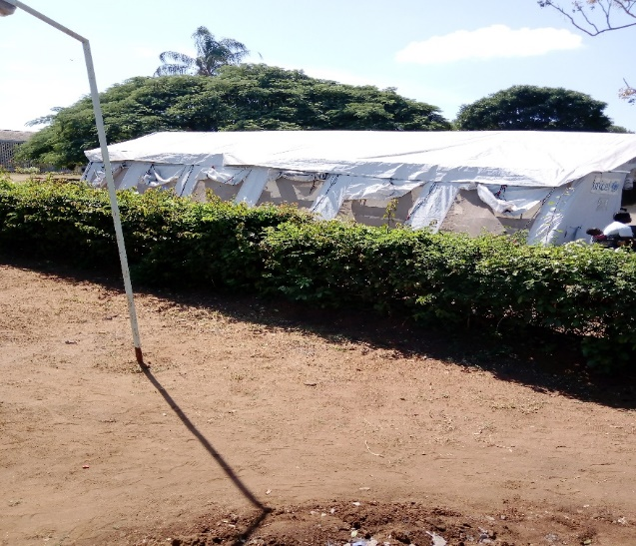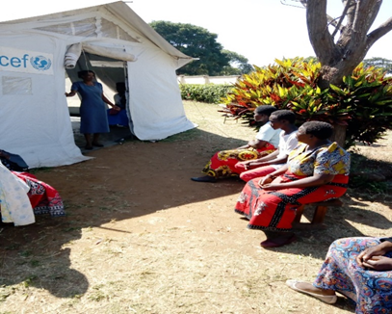
First tent where screening is done

An attendant welcoming clients, explaining to them what to be done in the tent.
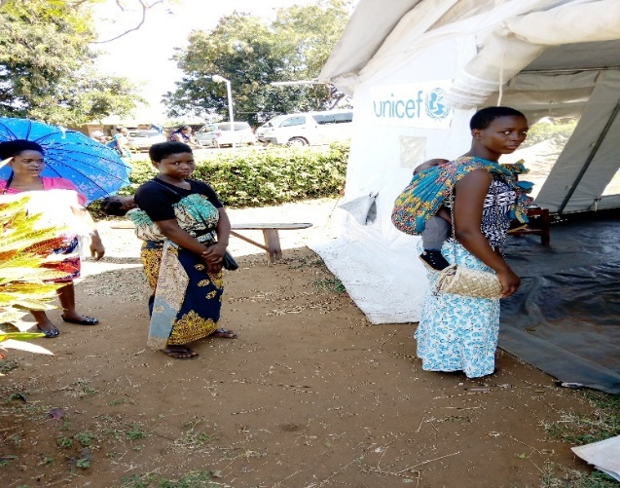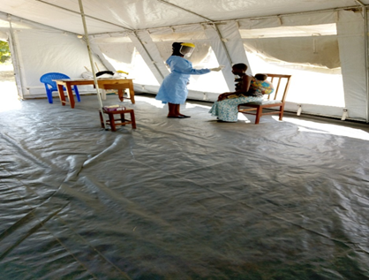
Clients proceeding to a tent for screening Inside a tent, a nurse and a client.
The second tent is used for treating patients with COVID 19 symptoms like coughing and history of travel to high risk countries and areas within the country
We are doing our best to provide safety to our patients and staff but for how long.
Sr Clotilda Makweya, Principal Hospital Administrator

