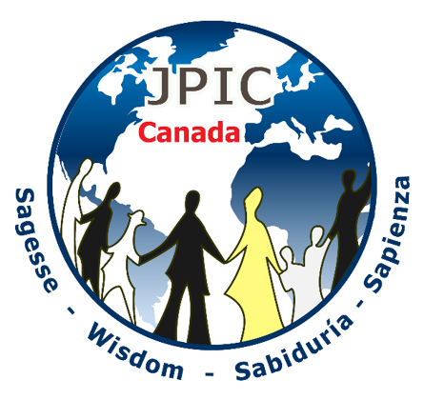
REFECTION GRID
International Day against Human Trafficking
July 30th 2020

This year of 2020 highlighted by the Covid-19 pandemic, the proposed reflection grid, was prepared around the effects of Covid-19 on victims of human trafficking. The principal source of information is the document published by the « Action Committee for Internal and International anti-trafficking in Persons » under « Covid-19 and Human Trafficking”.

WHAT THE UNITED NATIONS HAVE TO SAY: (UN):
The UN warns of the great risks involving victims of human trafficking¹ :
- the restrictive measures of confinement limits the access to resources such as financial aid, support, social and police services. “Aid services to victims of trafficking are reduced to a minimum or totally absent.”
- The UN asked that countries maintain shelters and helplines accessible” in order to protect those who are at great risk. “Some shelters were closed because of the virus while others lack the necessary protective gear.”
- An investigation, initiated by the UN is currently underway involving victims of human trafficking and frontline responders, in order to draw a list of recommendations in specific situations found in the member States.
- The coronavirus increases the risk of trafficking, warns the UN “…border closures prevent victims from returning home. They also face delays in legal procedures and risk additional mistreatment or are simply abandoned by their abductor.²

INSTANCES INFLICTED ON VULNERABLE MIGRANTS IN CANADA:
In general, the condition of vulnerability endured by migrants, makes them prone to exploitation; lack of money, no access to work, risk of eviction from their house, etc. These precarious conditions can easily lead to trafficking, because in order to survive these persons are forced into accepting whatever means. What possible solutions for them? To lean toward prostitution? Work in unhealthy dangerous conditions? What else?

Reducing the conditions of vulnerability for the migrants constitutes one of the means of protection against exploitation and trafficking.
MOST VULNERABLE PERSONS DUE TO THE COVID-19 SITUATION
Polaris Institute in the United States, mentions domestic workers are losing their job because their employers are now at home with either no work or money³ and are left in greater danger of exploitation. The closing of borders has an impact for those women who wish to go back to their country to care for their own children.
Moreover, women who are actively working in prostitution with “sex traffickers are in the obligation of bringing money and a greater availability to the demands of the clients⁴ is requested of them.
The Police Department for the city of Montreal and the Quebec Provincial Police noticed a rise in sexual exploitation on the “Internet since the beginning of the Covid 19 confinement”. An explanation to the fact that “young people spend more time on line and risk becoming victims of this type of crime”.
worldwide
Poverty and exclusion heightened by the consequences of the Covid-19 pandemic put more people at risk in becoming victims of trafficking. Many agencies put it forward publicly.

In South Africa and in Malaysia, cases of modern slavery are reported. Women and men workers, often migrants, are confined in factories producing medical gloves. In Spain, undocumented migrants and without residence, work in agricultural zones without any protection against the Covid-19 virus.

additional sources of information :
- CathII :Internal and International Committee for the Action against Human Trafficking. http://www.cathii.org/
- www.interfaith-project-trafficking-personal-persons/
- www.vaticannew.va
- https://migrants-refugees.va/ : Service « Migrants and Refugees » from the Congregation of the Vatican for the service of Integral Human Development, taking charge of the number of adults and children victims of trafficking for the purpose of sexual exploitation, organ trafficking, of panhandling and forced delinquency. To help in the fight against human trafficking and slavery, this service wrote a document available to all: “Pastoral Orientations on Human Trafficking” that can be found at the following link: https://migrants-refugees.va/fr/traite-et-esclavage/

