I bring you news of great joy:
today a Saviour has been born to us,
Christ the Lord.
Luke 2: 10-11
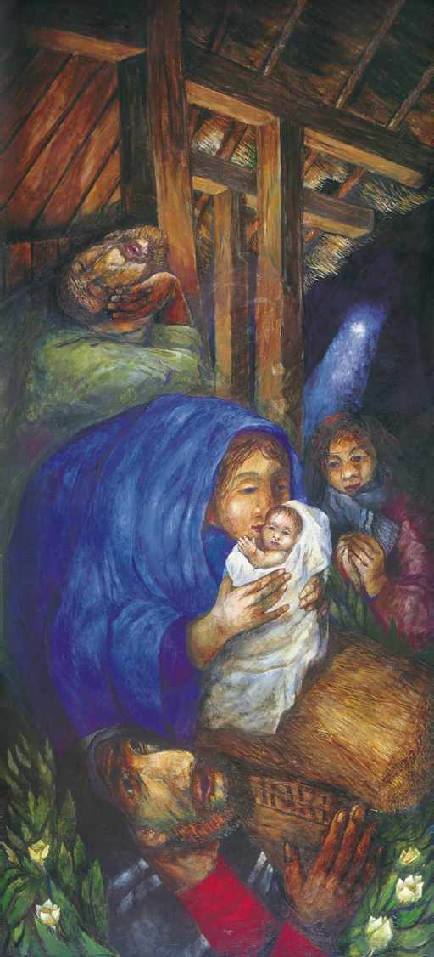

The Christmas Star is you,
when you lead someone to meet the Lord.
You are a Christmas Light,
when you illuminate with your life the path of others
with love, compassion, joy and generosity.
Pope Francis

Christmas 2020
A decree went out for a census 0f the whole world to be taken.
Luke 2:1-14
On Christmas day our waiting is over and the two searches —our seeking God and God seeking us — meet on the long journey from Nazareth to Bethlehem of Joseph and his betrothed, Mary, who was with child. Our Christmas cards, while beautiful, do not show the reality and Luke’s account of Christ’s birth give us a deeper glimpse into the trials Mary and Joseph had to endure. The journey from Nazareth to Bethlehem is about 90 miles and would take four days to reach there. Can you imagine what that was like for Mary, an expectant Mother?
On arriving in Bethlehem ‘there was no room for them at the Inn’ and Luke reports that Mary gave birth to Jesus and ‘laid him in a manger’ indicating that this was a stable where animals were kept. Pope Francis observes that
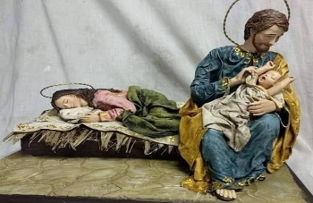
Mary experienced childbirth in a condition of extreme poverty; she could not give the Son of God even what Mothers would usually offer their new born baby; instead she had to lay him in a manger used by animals. Yet Mary was able to turn a stable into a home for Jesus, with poor swaddling clothes and an abundance of love.
Joseph is not mentioned at this point but the picture below of ‘Mary at Rest’ may help us to pause and reflect on Joseph’s hidden role in caring for Mary and her child. Consider how Mary and Joseph respond to these difficult circumstances.
Close by there were shepherds who lived
in the fields and watched their flocks at night.
Luke 2:8-9
The shepherds, having been visited by an angel are told ‘Do not be afraid. Listen! I bring you news of great joy, a joy to be shared by all people….a Saviour has been born to you; he is Christ the Lord.’ The people of Israel had been expecting a powerful Messiah of the Royal Davidic line who would save them from their enemies. Israeli leaders might have been expected to visit this long awaited Messiah but instead the only visitors at this time were lowly shepherds from the bottom rung of Jewish society who came in haste to witness the arrival of their Lord in a place of poverty. Mary prayerfully ‘kept all these things, pondering them in her heart’. In a short time Mary and Joseph and Jesus would have to flee to Egypt to escape persecution by Herod and so became refugees in a foreign land, living as a poor and marginalised family with little support. What may we learn from Mary and Joseph this Christmas? Take some moments to ponder on the difficult circumstances of Jesus’ birth. The ‘yes’ of Mary at the Annunciation was the total gift of herself to God and Joseph’s own ‘yes’ of faithful and loving support of Mary and Jesus inspires us to understand and live what it means to Love without borders.
As we celebrate the joyful feast of
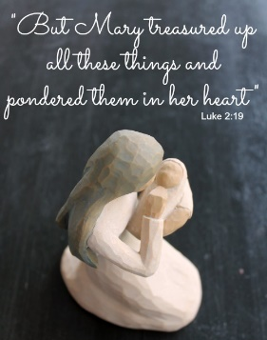
Christmas and God dwelling among us,
let us remember in prayer those, who like
the Holy Family are marginalised and
pushed to the edge of society.
May our witness bring light,
joy and peace to all peoples.
There is a child born for us,
a Son is given to us. Isaiah 9:5
At the dead of night,
a Light in the darkness for a child is born.
The promise at last becomes
flesh and blood,
Spirit and truth.
For a people walking in darkness
the true Light comes into the world!
A Light shining in the darkness-
a Light the darkness cannot overcome.
A baby treasured,
a Mother’s heart pondering
the meaning of God’s gift.
Cross-beams loom over Mother and child,
the same message
proclaimed by crib and cross.
Have we come to witness a birth or a death?
The mystery of birth and death calls us.
A sign of contradiction that will pierce
many hearts with a sword
so that the secret thoughts of many
may be revealed.
The crib and the cross are one.
Gemma Simmonds
Christ our Morning Star, to you our deepest night is clear as the day. O Christ, we praise you, because by your life and death
you have redeemed the world.

